C:\Users\traecit2\Desktop\excelsoft_logo.png

***VM CREATION***



| Document Details | |
| --- | --- |
| Type Of Information | **Document Data** |
| Document Title | VM Creation |
| Document Reference Number |  |
| Document Owner |  |
| Security Classification |  |
| Review Frequency |  |

| Document Approval | | | |
| --- | --- | --- | --- |
| Name | **Role** | **Signature** | **Date** |
| Mahesh Jambardi | Chief Operating Officer | Mahesh Jambardi |  |
| Srinivas Chudamani | Sr. Manager IT & IS Infrastructure | Srinivas Chudamani |  |

| Version Control Details | | | |
| --- | --- | --- | --- |
| Version  Number | **Revision Date** | **Prepared by** | **Nature of Change** |
| 1.0 |  |  |  |
| 2.0 |  |  |  |
| 3.0 |  |  |  |
| 4.0 |  |  |  |
| 4.1 |  |  |  |
| 4.2 |  |  |  |
| 4.3 |  |  |  |
| 5.0 |  |  |  |

**Table of Contents**

[**1.**](#_heading=h.30j0zll)  **4**

[**2.**](#_heading=h.2et92p0)  **4**

[**2.1.**](#_heading=h.tyjcwt)

[**3.**](#_heading=h.lnxbz9)  **9**

[**3.1.** 9](#_heading=h.35nkun2)

[**4.**](#_heading=h.1y810tw) **REFERENCE 11**

**Steps:**

# **Sign in to Azure Portal**

Go to the Azure Portal.

Sign in with your Azure account credentials.

# **Create a New Virtual Machine**

* In the Azure portal, click on **"Create a resource"** in the left-hand menu.
* In the "Search the Marketplace" box, type **"Virtual Machine"** and select **"Virtual Machine"** from the search results.
* Click **"Create"** on the Virtual Machine page.

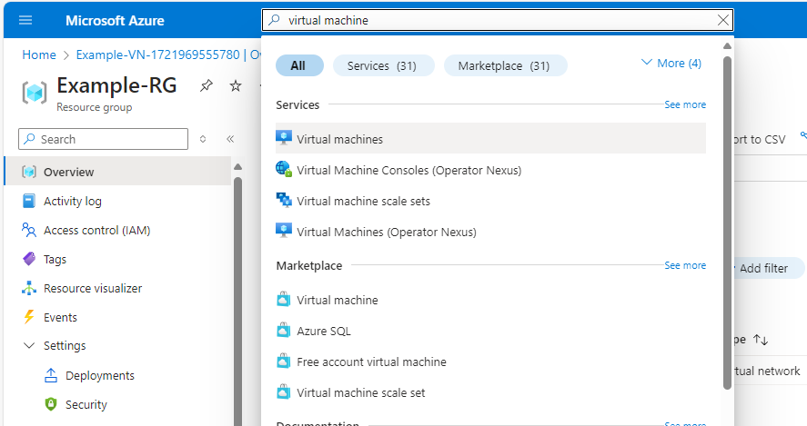

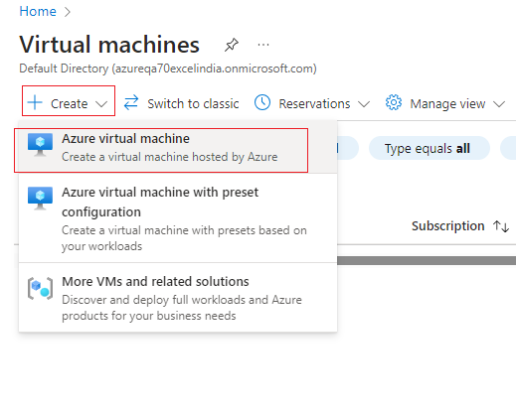

# **Configure Basic Settings**

* **Subscription**: Select the Azure subscription you want to use.
* **Resource Group**: Choose an existing resource group or create a new one by clicking **"Create new"** and providing a name.
* **Virtual Machine Name**: Enter a name for your VM.
* **Region**: Choose the Azure region where you want to deploy the VM. Select a region closest to your users for better performance.
* **Availability Options**: Select an availability option based on your redundancy needs (e.g., Availability Zone, Availability Set).
* **Image**: Select the operating system image you want for your VM (e.g., Windows Server, Ubuntu).
* **Size**: Choose the VM size based on your required CPU, RAM, and storage. Click **"Change size"** to view and select different options.
* **Authentication Type**: Choose between SSH public key (for Linux) or password (for Windows) authentication.
  + For **Password**: Enter a username and password.
* **Inbound Port Rules**: Configure the inbound port rules to allow traffic. By default, SSH (port 22) or RDP (port 3389) is enabled based on the OS you selected. You can add or remove rules as needed.

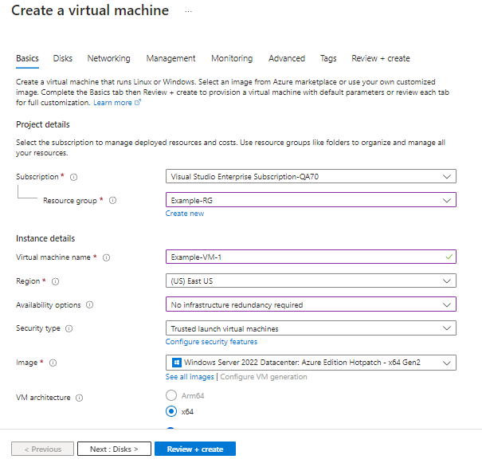

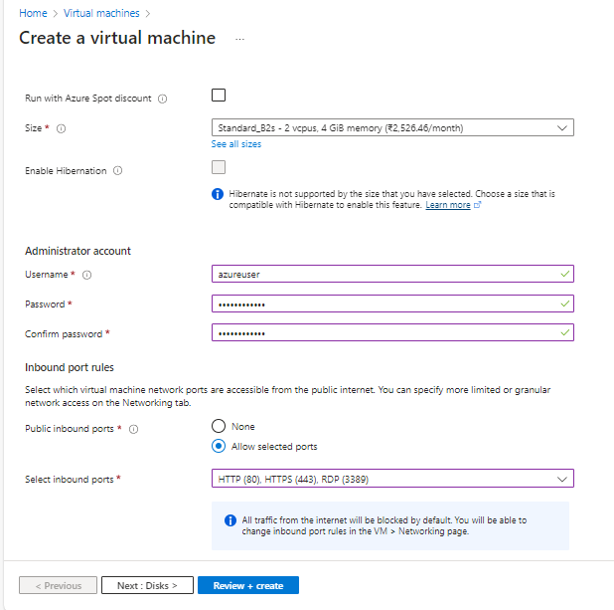

# **Configure Disks**

* **OS Disk Type**: Choose the type of OS disk (e.g., Standard SSD, Premium SSD).
* **Additional Data Disks**: Add additional data disks if needed by clicking **"Add new disk"**.

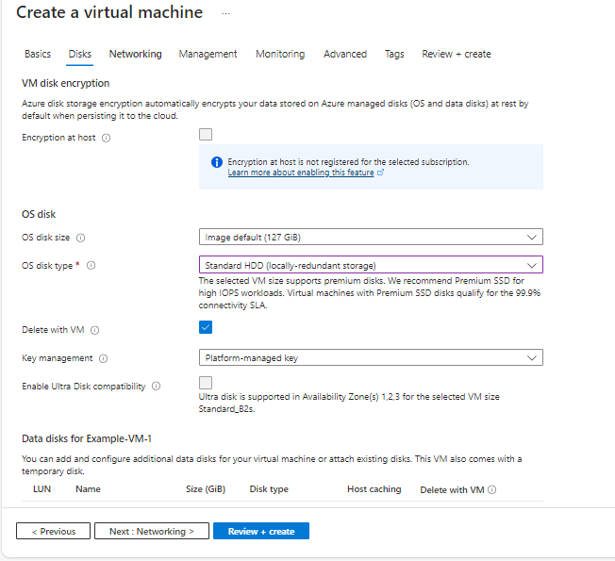

# **Configure Networking**

* **Virtual Network**: Select an existing virtual network or create a new one by clicking **"Create new"**.
* **Subnet**: Select an existing subnet or create a new one.
* **Public IP**: Choose whether to create a new public IP address or use an existing one.
* **Network Security Group**: Use an existing Network Security Group (NSG) or create a new one.
* **Load Balancer**: Select whether to associate a load balancer if needed.

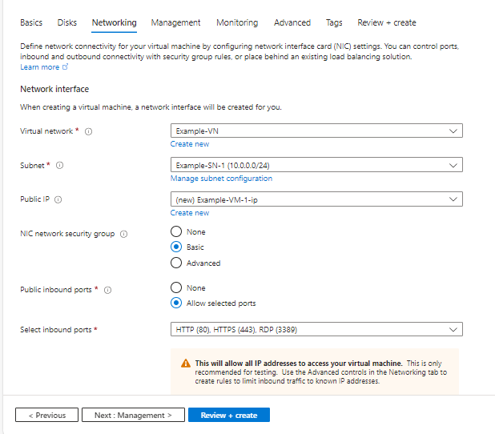

### 

### 

### 

### 

### 

### 

### 

### 

### 

# **Review and Create**

* **Review + Create**: Review your configuration settings. The portal will check for any issues and indicate if anything needs to be fixed.
* **Create**: If everything is correct, click **"Create"** to start the deployment process.

### 

### 

### 

# **Deployment**

* The deployment process will take a few minutes. Once completed, you’ll see a notification that the VM has been successfully created.
* Go to the **"Virtual Machines"** section in the Azure portal to view and manage your new VM.

### 

### 



 

 